**A**

**Project Report**

**On**

**"3Games"**

**Prepared by**

Ansari Amir(19dce002)

Sanat Kakadiya(19dce050)

Anshul Gorasiya(19dce034)

**Under the guidance of**

Prof.Bhavika Patel

A Report Submitted to

Charotar University of Science and Technology

for Partial Fulfilment of the Requirements for the

4th Semester Software Group Project-II (CE255)

**Submitted at**



**CE**

**DEPSTAR**

**At: Changa, Dist: Anand – 388421**

**APRIL 2021**



**CERTIFICATE**

🡪This is to certify that the report entitled “**3Games**” is a bonafied work carried out by Ansari Amir(19dce002),Sanat Kakadya(19dce050) and Anshul Gorasiya(19dce034)under the guidance and supervision of Prof.Bhavika Patelfor the subject CE255 **Software Group Project-II** (CE) of 4th Semester of Bachelor of Technology in **DEPSTAR** at Faculty of Technology & Engineering – CHARUSAT, Gujarat.

🡪To the best of my knowledge and belief, this work embodies the work of candidate himself, has duly been completed, and fulfils the requirement of the ordinance relating to the B.Tech. Degree of the University and is up to the standard in respect of content, presentation and language for being referred to the examiner.

|  |  |
| --- | --- |
| Prof.Bhavika Patel  Prof Binal Kaka  Branch Name(CE)  DEPSTAR, Changa, Gujarat. |  |
| Dr. Amit Ganatra  Principal, DEPSTAR  Dean, FTE  CHARUSAT, Changa, Gujarat. | |

**Devang Patel Institute of Advance Technology And Research At: Changa, Ta. Petlad, Dist. Anand, PIN: 388 421. Gujarat**

**ACKNOWLEDGEMENT**

* We, the developers of a library management system named “3Games”, with immense pleasure and commitment would like to present the project assignment. The development of this project has given me wide opportunity to think, implement and interact with various aspects of management skills as well as the new emerging technologies.
* Every work that one completes successfully stands on the constant encouragement, good will and support of the people around. I hereby avail this opportunity to express my gratitude to number of people who extended their valuable time, full support and cooperation in developing the project.
* We express deep sense of gratitude towards our Head of the CE Department, Dr. Amit Ganatra and project guides Bhavika patel and Prof Binal Kaka for the support during the whole session of study and development. It is because of them, that I was prompted to do hard work, adopting new technologies.
* Thanks,

Ansari Amir

Sanat Kakadiya

Anshul Gorasiya

**ABSTRACT**

For software group project-II we wanted to focus on web development not only for this project but for also for the development of our career. To hone our skills in web development we wanted to make a project that nurtures our basic html css and js skills by creating a website.

As mentioned above, we came up with the idea of developing a website to nurture our basics once again and decided to make a website that has 3 games in it.

The 3 games in it are named as puzzle world, memory card game and finding image game.

**Table of Contents**

Cover Page……………………………………………………………………………………1

Certificate……………………………………………………………………………………..2

Acknowledgement…………………………………………………………………………….3

Abstract………………………………………………………………………………………..4

Project Definition……………………………………………………………………………..6

Description……………………………………………………………………………………6

Tools and system requirements…………………………………………………………………7

Screenshots from the website …………..………………………………………………………8

Limitations of the project…………………………..…………………………………..………12

References………………………………………………………………………………..……13

**Project Definition and Description**

🡪games3.epizy.com is a website which by its name describes that it has 3 games in it. As we start the website first it shows the homepage from where u can contact us, find more about the game or do what it was made for-play the game.

🡪The games3.epizy.com in it are puzzle world, memory card game and finding image game.

In the puzzle world game a large image is broken down into 9,12 or 15 small images which is jumbled together. What you have to do is slide the images and make it like shown on the right.

🡪The memory card game Click on the cards or press the keyobard keys to reconstruct the pairs of birds by turning them 2 by 2 and discover the image hidden underneath! If the cards turned face up are the same (a pair), you win and the pair disappears from the game Otherwise the cards are automatically turned face down and you need to make a new try!

🡪The third game is simple as its name you have to find a particular thing which is asked of you in a big picture like where’s waldo puzzles

**Tools and technology used**

🡪The whole web development project is made in **vs code.**

🡪For the body we have used **html.**

🡪Styling is done in **css3.**

🡪the logic of the games are written in **javascript.**

🡪And you will need a browser to run the website.

**Screenshots from the website**

1.Homepage

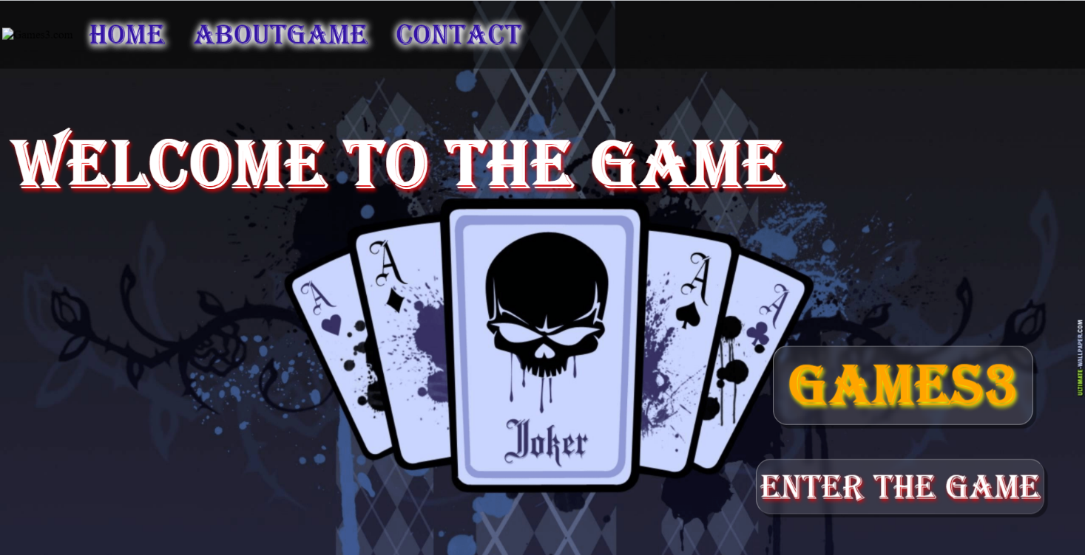

2.About us page

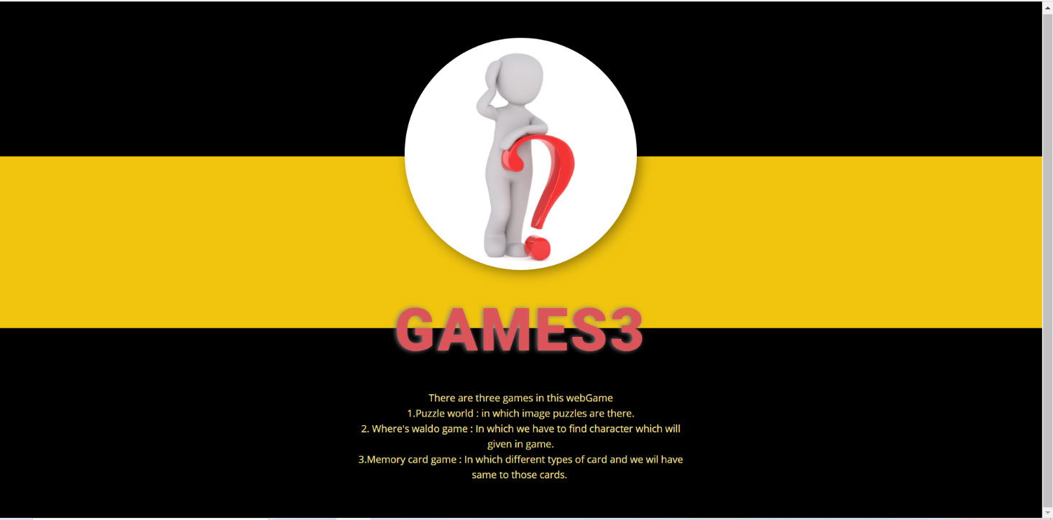

3. Contact us page

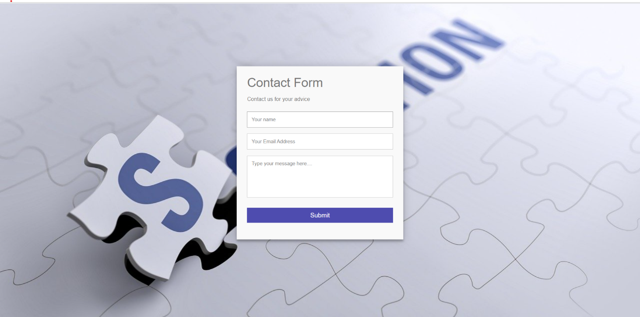

4.Second page

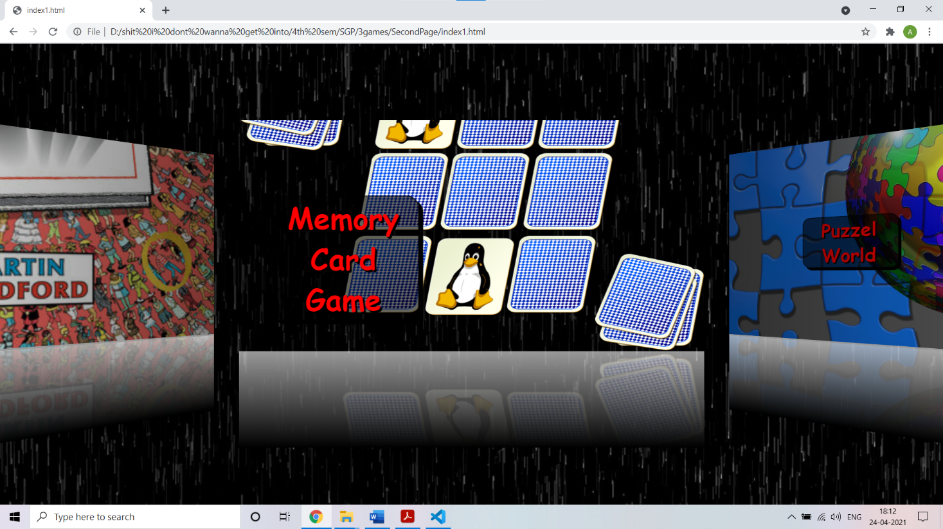

5. First game

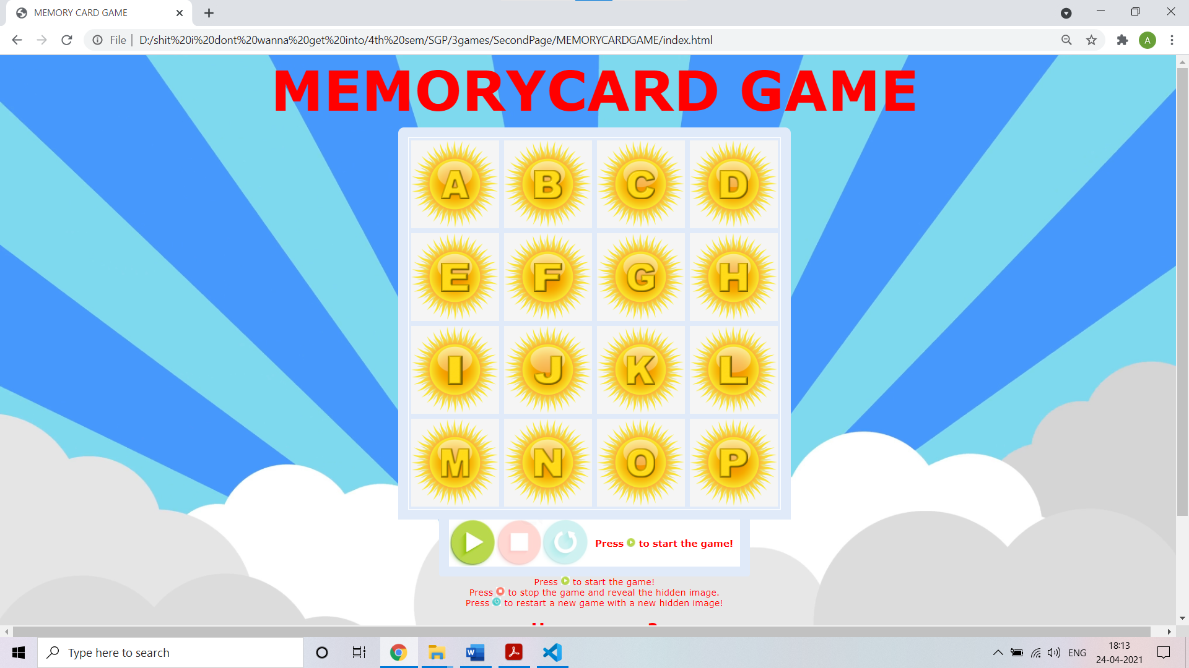

6. Second game

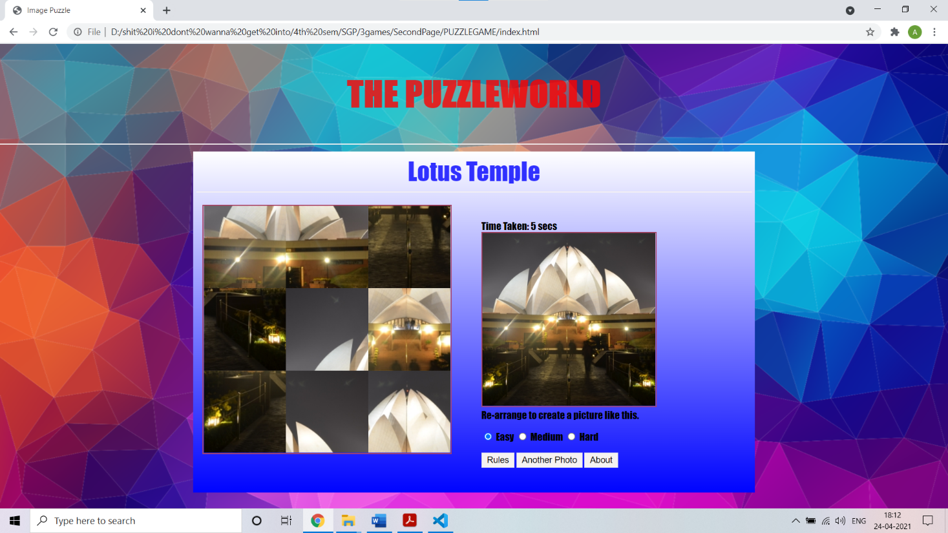

7. Image finding game

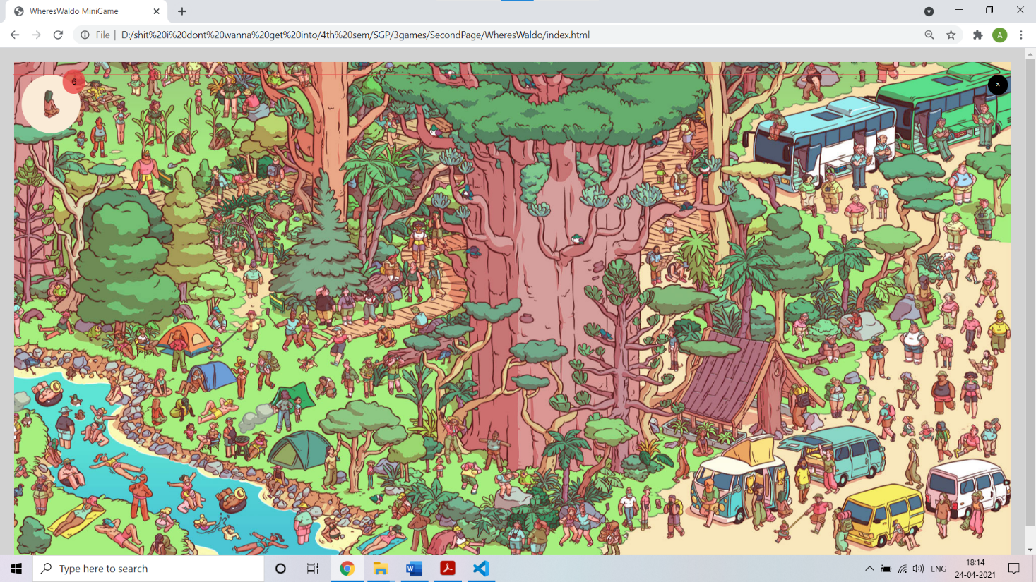

**Limitations of the project**

🡪The website made by us is not for professional use therefore it is not hosted.

🡪It is meant for self-educational purposes.

🡪The website is not responsive.

🡪The games are simple and easy.

🡪Games do not have large logic or is not much interesting .

**References**

* <https://codewithharry.com/playlist/web-development>
* For images : <https://pixabay.com/>
* <https://www.youtube.com/watch?v=QocWxqA28Ds&list=PLbu98QxRH81KxxMclY_ZRmm4Dac-n7cSA>
* [https://nicepage.com](https://nicepage.com/)